Assignment One
Ima Strong Student
Section CNQ
Lamar University

Title of Your Report (which is “Assignment One”)
Write your introduction here in paragraph form. Introduce the paper and what you will be discussing in 3-5 sentences. Side note: you will likely need a minimum of 5 pages of writing in addition to you cover page, reference list, and chart to provide the information necessary to fulfill the rubric.
Overview of Topic
Description and rationale for the topic as relating to the counseling field.
Regarding this part of the rubric that states you need 5 references. You need to cite 5 references here. You can cite more than one in the same sentence in some cases if they state similar points. For example, if my topic is the use of social stories by school counselors I might state “Although social stories have long been used within the field of special education (Gray, 2007), within recent years, a plethora of research has been published to demonstrate how school counselors have successfully used social stories to improve situational understanding and the behavior of elementary students in the general population (Goodman-Scott & Carlisle. 2015; Smith, 2016; Tray & Harris, 2015). As a result social stories have become a viable tool for use for elementary level school counselors (Smith, 2017). The whole point of this section is to build an argument and rational for your topic. The articles you use here have to be studies.
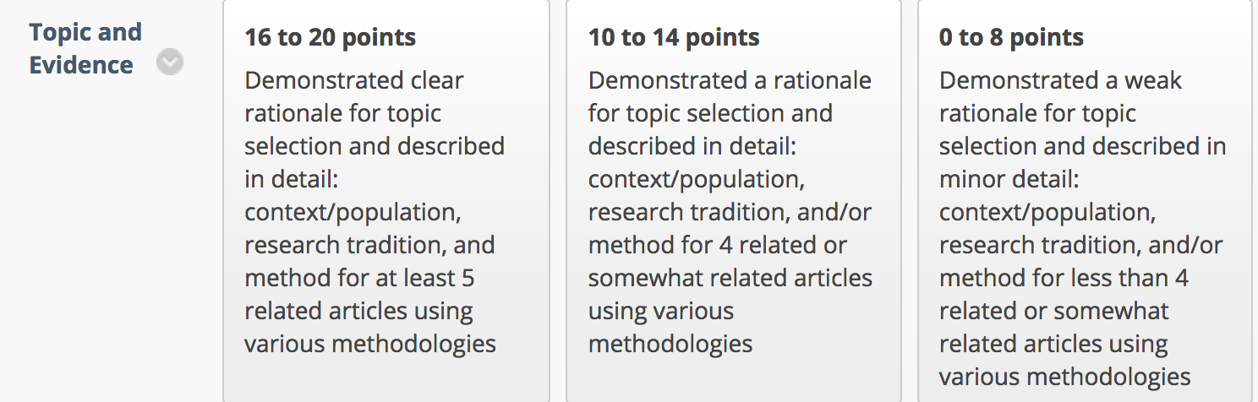

In addition to the above section of the rubric I copy and pasted, there is also a rubric area call Writing Style that should be followed throughout your paper. The section specifically states “Writing is reflective of all areas: (a) critical examination with respect to culture and/or social norms, (b) reasoned reflections with respect to the field, (c) new ideas based on evidence/argument using sources. APA format is used and writing has no or few grammatical errors.” This section here is where you can accomplish talking about how your topic is important in terms of cultural, make sure you connect your topic to the field of counseling/your future field, and you can discuss how understanding this topic further can help you develop new ideas for practice. You can also discuss these points in your methodology and/or your reflection section. Thus, this section, your methods section, and your reflection section are the best places in my opinion to address these rubric points. Depending on how you address the rubric points you could discuss parts of all these points (a,b,c) in this section, your methods section, and your reflection section…or you could discuss point ‘a & b’ in your methods section and reflection sections as ‘a & b’ relate to those sections and discuss c in this topics section. There is no one right way, these are just some of the ways. Make it clear to the reader that you are addressing these rubric points (like using part of the language in the rubric in your written work to alert the reader that you are addressing a rubric point) and thoroughly address the points with supporting details and logical thought. I am focusing specifically on this area of the rubric here in this outline I created for you not because it is most important, but because this specific rubric area (Writing Style) is often where I see students miss out on points the most.
Delete these directions prior to submitting.
Audit Trail
This section will include a narrative of your search process as well as a chart. Description of the search in a paragraph form, including the databases used the the journals selected for the chart. Document your search process, which is providing a transparent set of procedures as a type of audit trail. Too often students and researchers retrace their steps in doing literature searches. The purpose of this step is to get in the habit of keeping track of all your searches. For each step in your search, note your search terms and record how many references were returned as a function of how narrowly or broadly you defined your search. Use the chart at the end of this assignment.
Each time you broaden or narrow your search, scan through and get a rough estimate (if the search yields a manageable number of entries, you can get an exact count) of how many new hits you obtained. Document each time you focused the search. The following kinds of entries are possible: journal articles, conference presentations, unpublished manuscripts and dissertations, and non-English entries. However, each article will not be empirical research. You will need to peruse the abstracts and determine if the article is empirical research as well as to determine the method (qual, quan, mixed). Keep detailed notes.
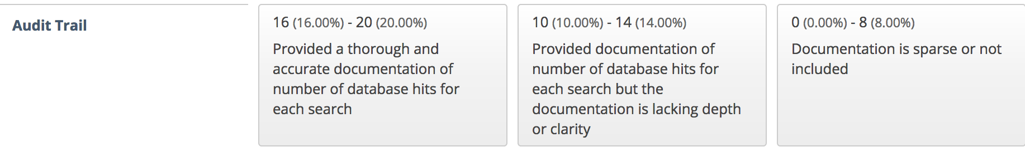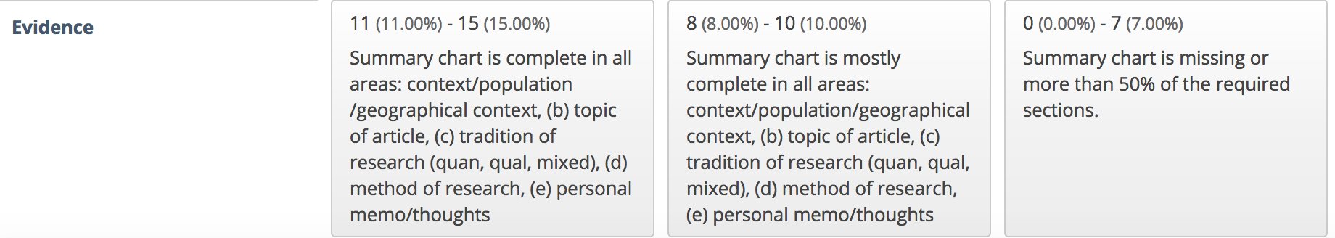

Delete these directions prior to submitting. Don’t delete the chart below. Complete the chart and keep it in this section or include it as an appendix at the end of the report.

Within the below table, 5 studies must be listed with complete information for the entire chart. In your overview of topic section of this paper, if you used studies in that section, then you may use the same studies or different studies here. How do you know if an article is a study? You will see that the article has a methods section and a findings/results sections. You will notice when reading that a methodology was followed, there were participants, data was collected, data was analyzed, and data was reported.
Table One: Audit Trail
Search term(s)/Boolean operator(s): |  |  | Databases | Number of hits (Results) | Other Notes:
Title of Article | Journal | Year of Publication | Research Tradition (Quan,Qual, Mixed) | Method | Context: Participants, Population, Location | Key Points in Article or memo and thoughts on article

Methodology
Description of quantitative, qualitative, and mixed research. Were the bulk of the empirical research studies in any specific tradition? Which articles resonated most with you and why? Make sure to briefly address the type of tradition for each of the 5 studies and discuss how that tradition was used to understand the findings.
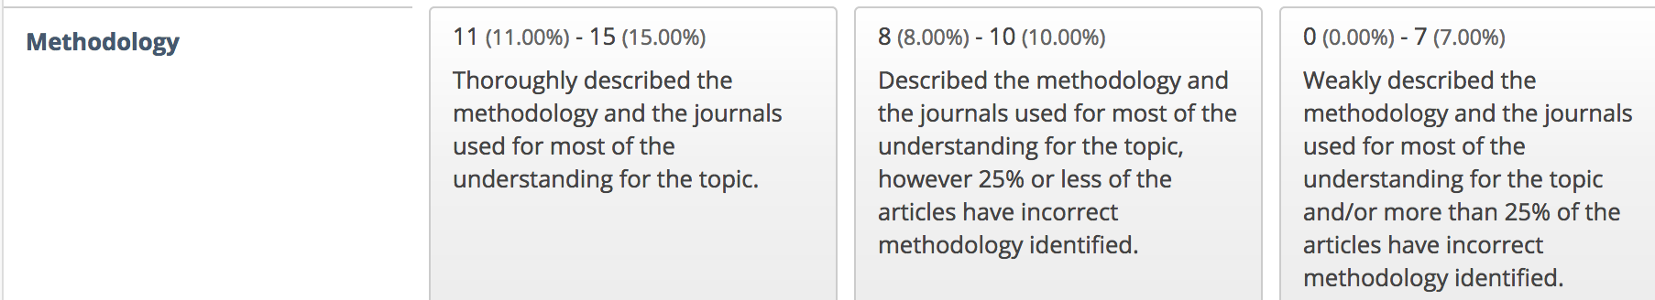
Delete these directions prior to submitting.
Reflection
What were some of the limitations of the articles you reviewed? Try to pick one limitation for each article. What are some of your own personal experiences relating to the topic? What did you select this topic….or what is the rational for why this topic is important…?
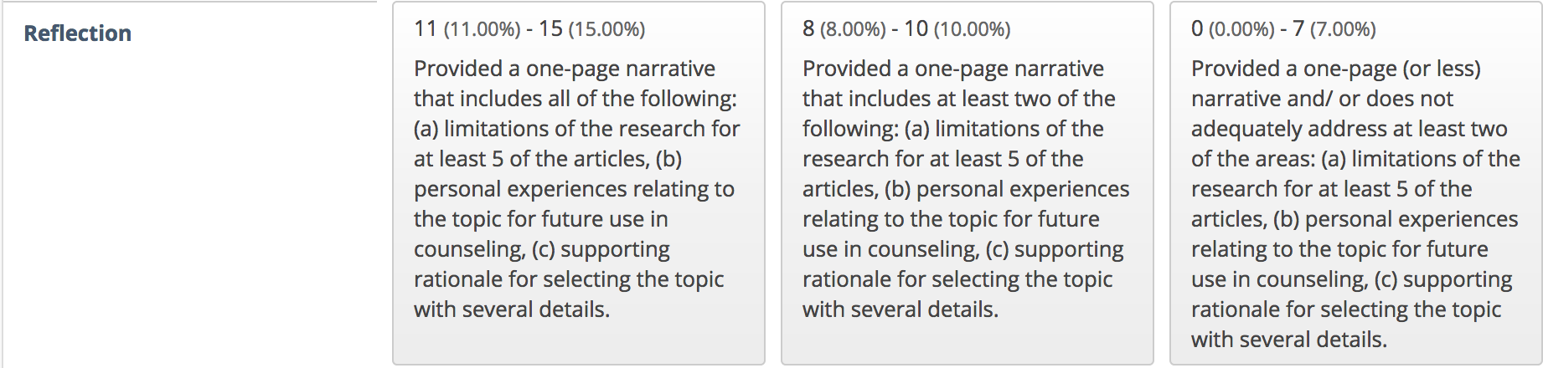
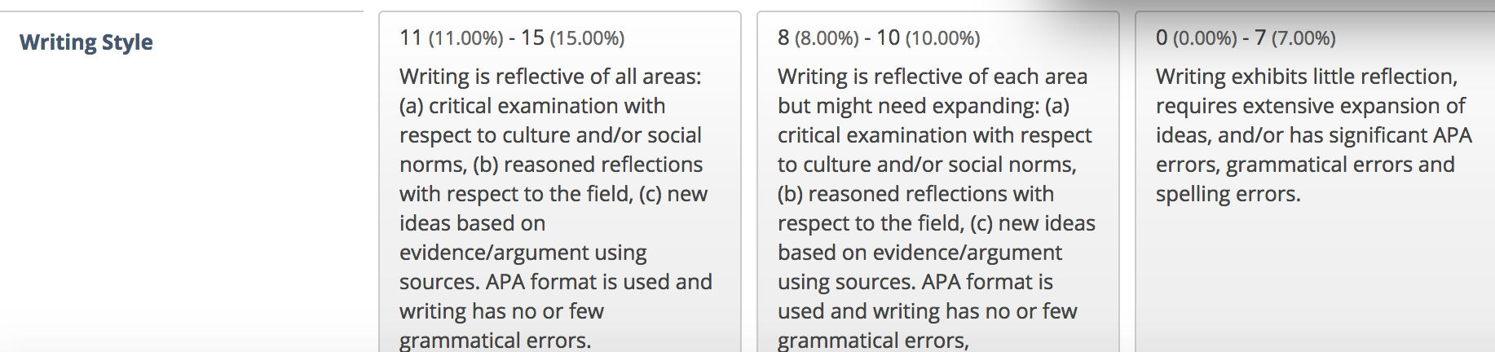

References
List all references used here in full APA.
See this link here for how to cite journal articles. Remember that the reference list should start on its own page. Be sure to include the references for each entry in the chart.
https://owl.english.purdue.edu/owl/resource/560/07/

Appendix A (if needed)
Audit Trail Chart

